CREATE TABLE employee (

employee_id NUMBER GENERATED BY DEFAULT AS IDENTITY,

first_name VARCHAR2(50) NOT NULL,

last_name VARCHAR2(50) NOT NULL,

basic_salary NUMBER(10, 2) NOT NULL,

conveyance_allowance NUMBER(10, 2),

next_salary NUMBER(10, 2),

CONSTRAINT employee_pk PRIMARY KEY (employee_id)

);

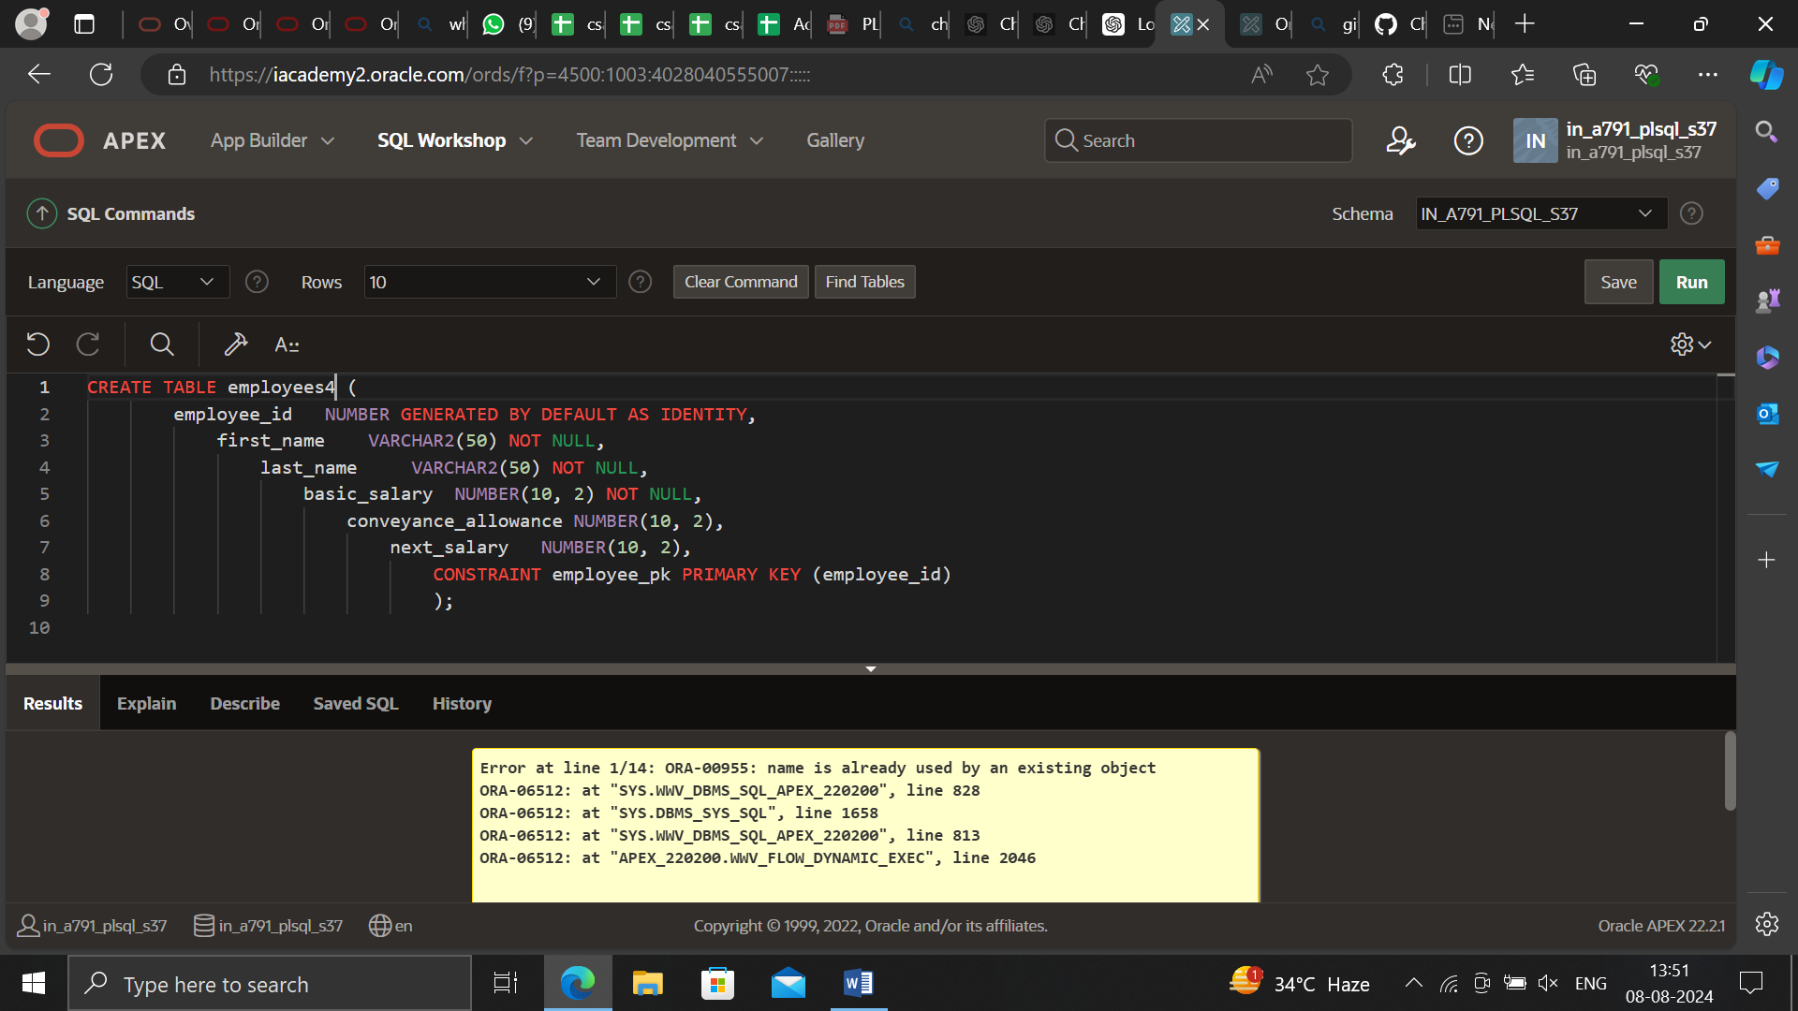

INSERT INTO employee (first_name, last_name, basic_salary)

VALUES ('John', 'Doe', 50000);

INSERT INTO employee (first_name, last_name, basic_salary)

VALUES ('Jane', 'Smith', 60000);

INSERT INTO employee (first_name, last_name, basic_salary)

VALUES ('Jim', 'Beam', 55000);

INSERT INTO employee (first_name, last_name, basic_salary)

VALUES ('Jack', 'Daniels', 65000);

INSERT INTO employee (first_name, last_name, basic_salary)

VALUES ('Jill', 'Valentine', 70000);

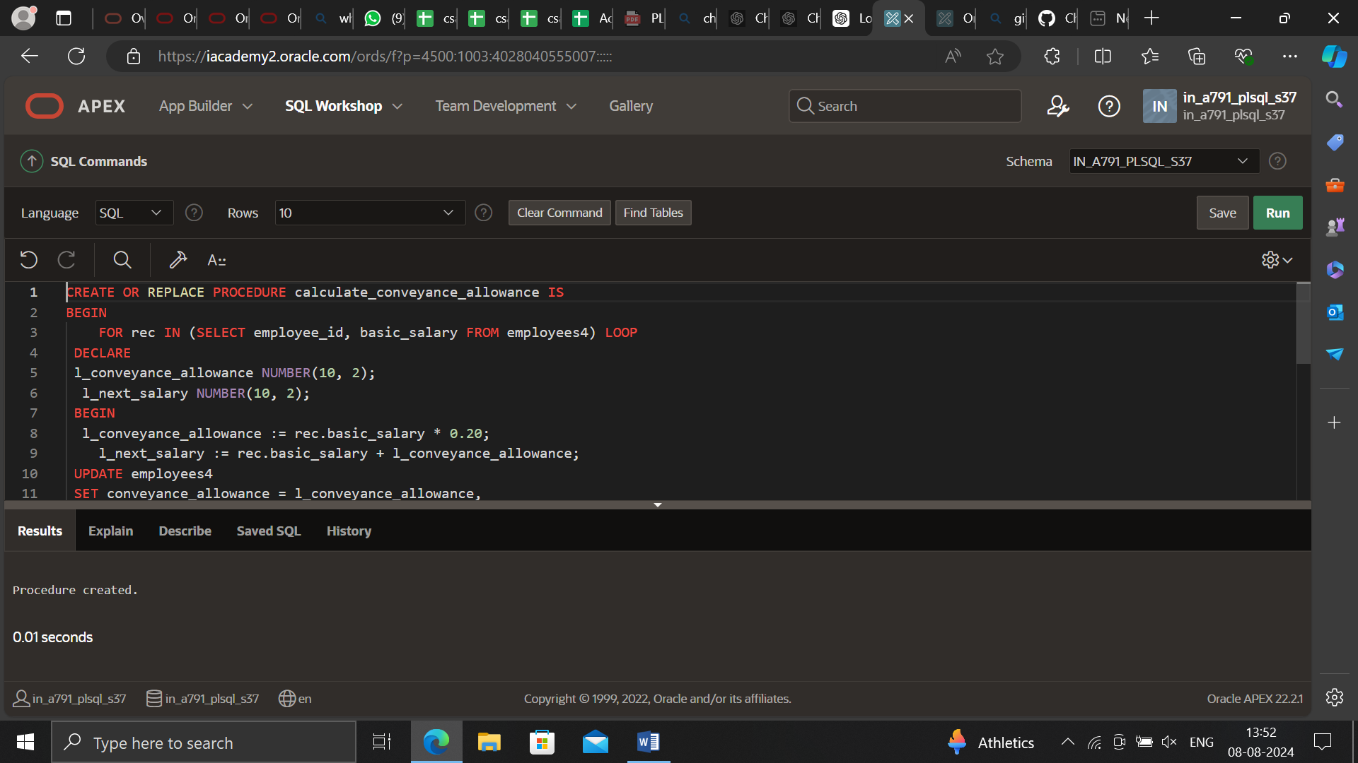

CREATE OR REPLACE PROCEDURE calculate_conveyance_allowance IS

BEGIN

FOR rec IN (SELECT employee_id, basic_salary FROM employee) LOOP

-- Calculate the conveyance allowance as 20% of the basic salary

DECLARE

l_conveyance_allowance NUMBER(10, 2);

l_next_salary NUMBER(10, 2);

BEGIN

l_conveyance_allowance := rec.basic_salary * 0.20;

-- Calculate the next salary by adding the conveyance allowance to the basic salary

l_next_salary := rec.basic_salary + l_conveyance_allowance;

-- Update the employee record with the conveyance allowance and next salary

UPDATE employee

SET conveyance_allowance = l_conveyance_allowance,

next_salary = l_next_salary

WHERE employee_id = rec.employee_id;

END;

END LOOP;

-- Commit the changes to the database

COMMIT;

END calculate_conveyance_allowance;

/

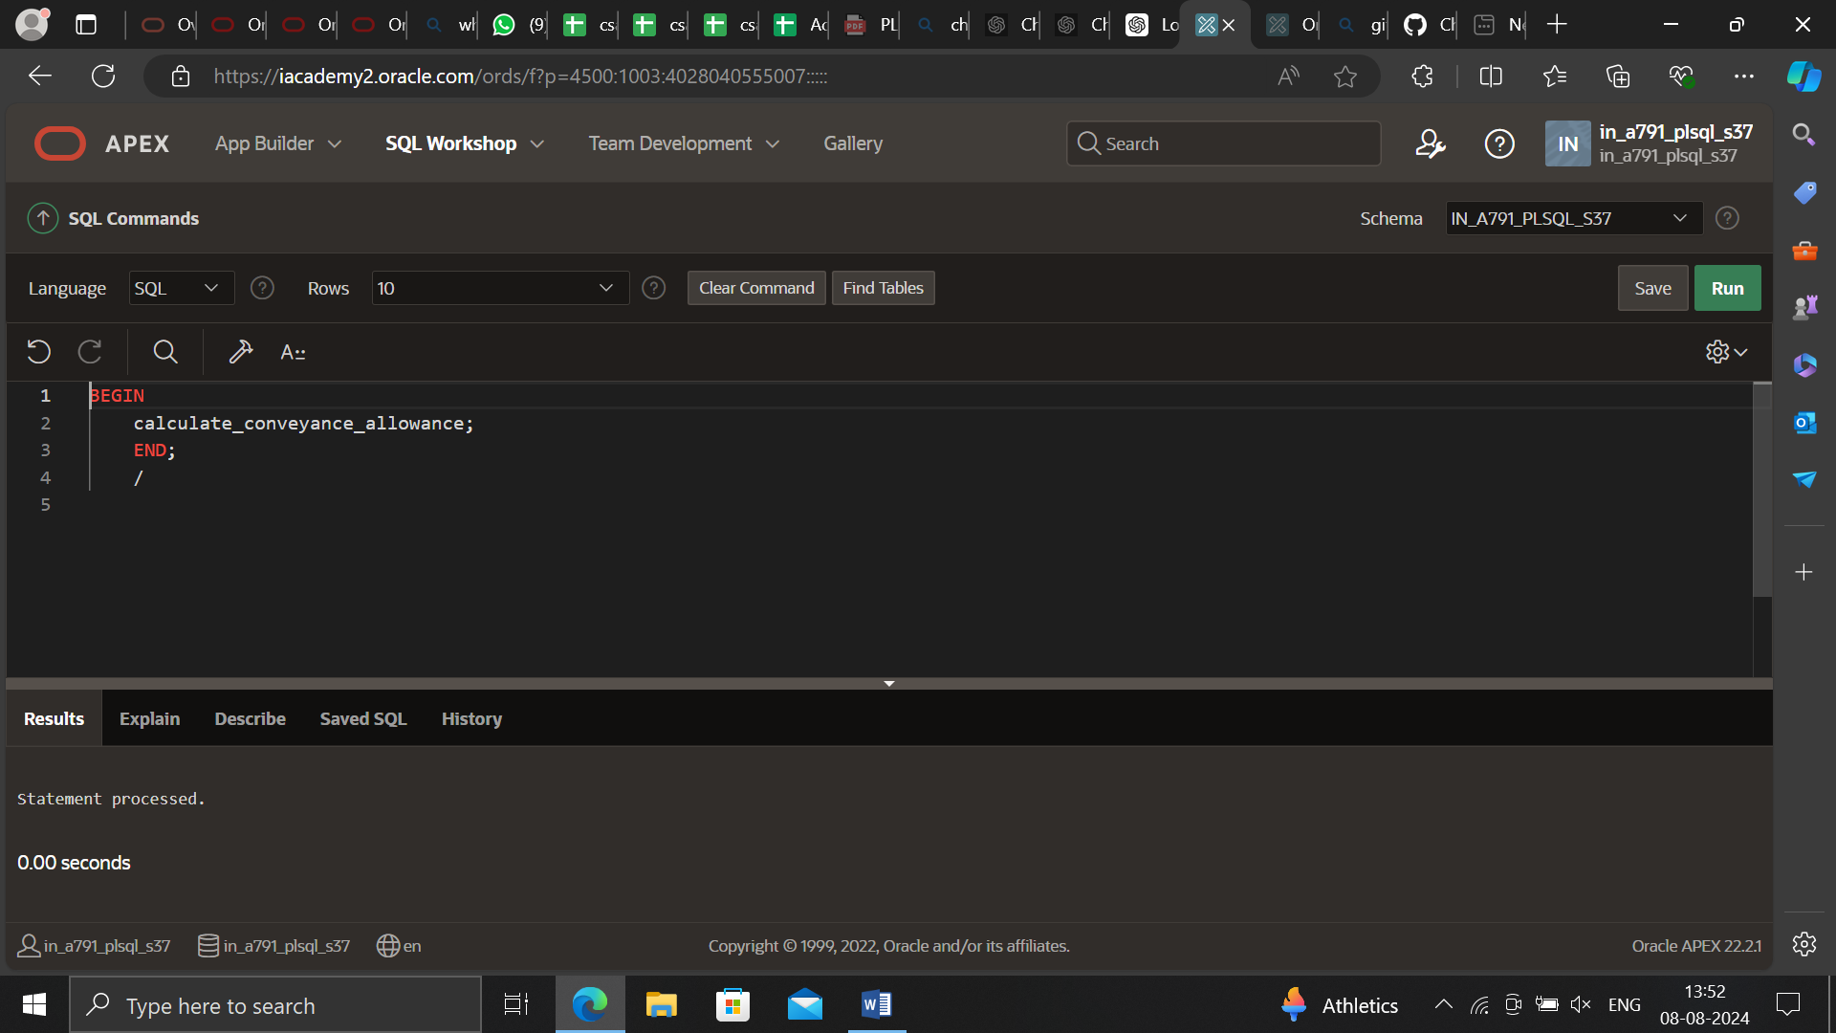

BEGIN

calculate_conveyance_allowance;

END;

/

SELECT * FROM employee;

